Final Project Proposal – Perfect Paws – Jaymes Bunce

Purpose:

If you are an avid pet owner like me then there are many times where it would be handy to have the information about your animal at a glance. There are many occasions in which I wish I had a way to easily check the information about my animals. Now there is with Perfect Paws!

For example, I have a dog named Bruce but sometimes I forget items such as: when his last shots were, when the last time we went to the vet was, when his next visit to the vet is, his birthdate/dog age, suggestions/notes from the vet from the last visit, information about what a healthy lab-retriever mix should be (such as a healthy weight for my dog), what medicine he needs to take an how frequently, and I wish I had a place to upload receipts or documents from vet visits.

There are many applications currently that allow me to track my health and information but I want to create one that's designed for a pet owner and some of the items they would like in a application. The end goal of the application will allow the user to save and customize the information of their pet while allowing quick and easy access.

Audience:

My main target user would be any person who owns a dog. Specifically, for this application I would be targeting dog owners as according to spots.com “over 63.4 million or 53% of American households own a dog “. This means that there would be a big market to cater to if I were building this application to be a source of income. I also wanted to focus on making something that I would personally use and that I feel friends and family who own animals would want to use as well. I talked with friends and family who own animals and got their suggestions on what they would like in an application such as Perfect Paws.

Some of the main items I found people were looking for were:

* Dates of shots or vaccines
* Medications for the animal and frequency of medications.
* More information at a glance of what is considered healthy for their breed of dog.
* A place to store receipts and documents about their pets such as visits to the vet.
* A place to store notes taken during the vet visit about specific doctor’s instructions for their animal.

Data Sources:

1. The main data source would be through local storage. Once a pet owner has entered the information about their animal the application would take the pet as an object and convert it to JSON and then store this in local storage. This way the pet owner will always have access to the information and if I were to ever add to the application, I could use the JSON in parts of the application.
2. The second data source I would like to use in this application would be a dog API. <https://thedogapi.com/> is an API that has many of the breeds of dogs along with information about their personalities, typical weights, typical heights, and average lifespan. this information would be based on what breed selected by the pet owner when the information is entered. It will display below the personal information about their pet.

Initial Modules List:

1. getOrSetLocalStorage.js
   1. This module would be used to get the current pets from the local storage or save the pets to the local storage.
   2. This would also include the code to convert the pet objects to JSON.
   3. This module would also include the retrieval and saving of document/images to the local storage.
2. petView.js
   1. This module would be used to display/render the pet list on the main screen.
   2. This module would be used to display/render the details of a specific pet.
   3. This module would be used to display/render the information from the dog API.
   4. This module would be used to display the documents or images associated with a pet.
3. petController.js
   1. This module will be used to control the functions/methods of the petView an petModel modules.
4. petModel.js
   1. This module be used to retrieve and manipulate the data between the application and the getOrSetLocalStorage module.

Wireframes/Colors/Typography/Element Styling:

Main Pet List View:

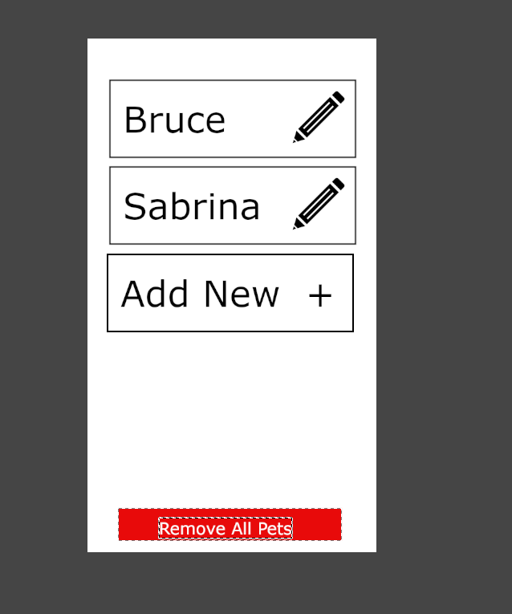

Add Pet View:

Pet Details View and API Information:

\*Note Date of last visit will be a button when pressed will display notes

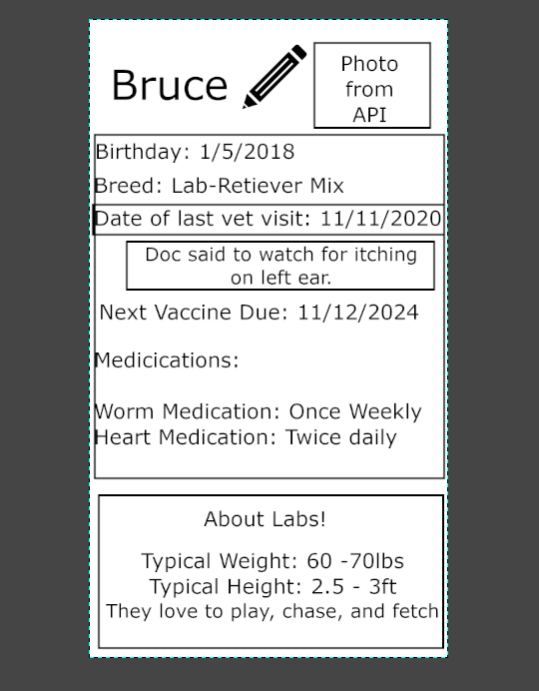

Pet Details View, API Information Continued with Documents/Images:

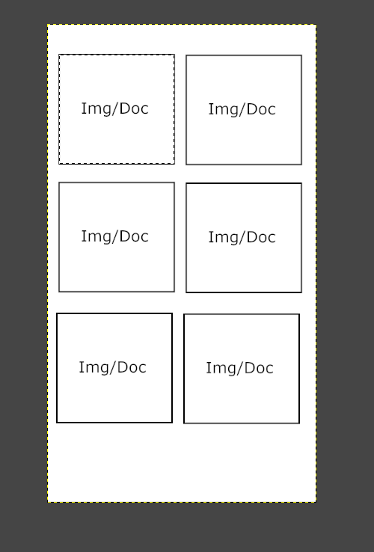

Colors:

\*I will probably change this later but right now I am liking this color platte

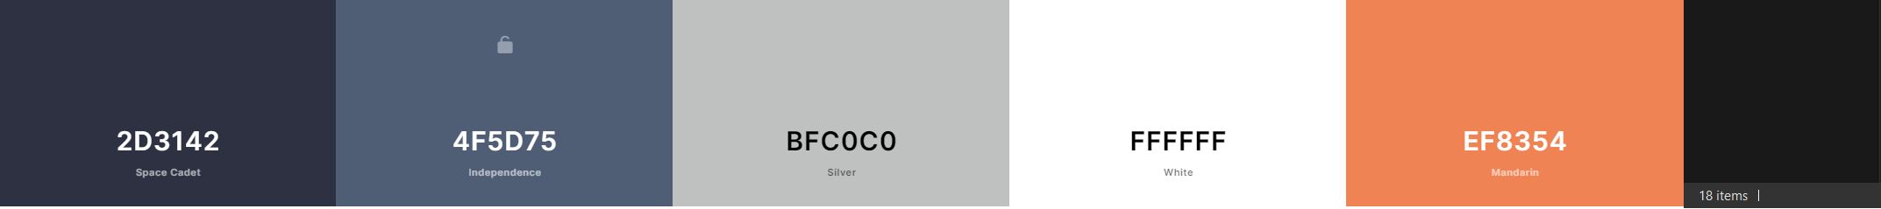

Schedule:

1. Week 10 End Week Goals:
   1. Basic HTML layout.
   2. General CSS in place to match design from wireframes.
2. Week 11 End Week Goals:
   1. Ability to add pets.
   2. Ability to save pets as JSON to local storage.
   3. Ability to retrieve JSON pets from local storage.
   4. Display pets in main list view and detail view.
3. Week 12 End Week Goals:
   1. Ability to pull information about specific breed from API.
   2. Displaying information about specific breed from API.
   3. Pull list of breeds from API and use this when adding pets as the list in the drop down for the breed
4. Week 13 End Week Goals:
   1. Add ability to upload pictures or documents for each pet
   2. Save documents or images to local storage.
   3. Retrieve documents or images from local storage.
   4. Display documents or images on pet details.
5. Week 14 End Week Goals:
   1. Optimize code and clean up code.
   2. Final bug testing/error handling testing
   3. Submission!